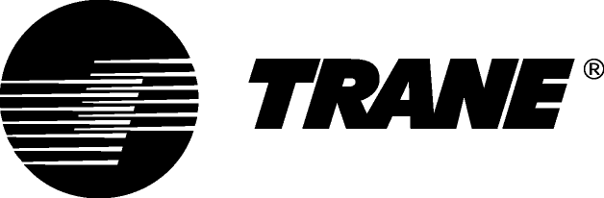

Guide Specifications

City™ Water-cooled Chillers and Water/water Heat Pumps with Screw Compressor

Model RTSF G with R1234ze refrigerant

180 - 385 kW

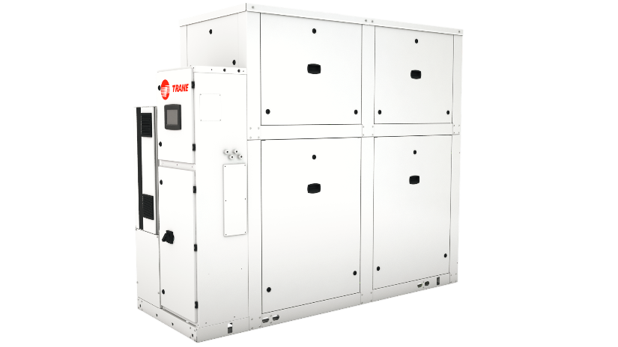
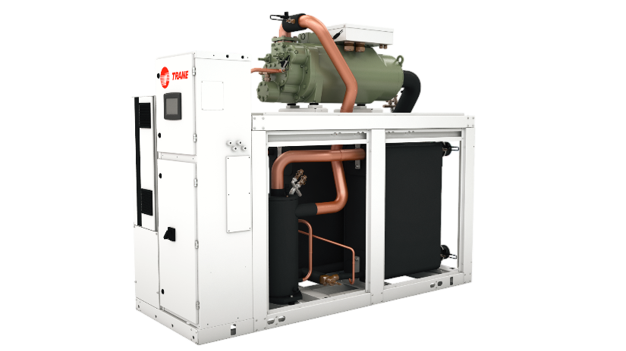

May 2020 RLC-PRG036B-GB

General
Chilled or hot water production will be made by a factory-assembled and tested water-cooled liquid chiller/water-to-water heat pump, Trane type RTSF G which will be shipped with a full operating charge of R1234ze refrigerant and lubrication oil, screw compressor and electronic expansion valve.

Unit panels, frames and exposed steel surfaces shall be painted with an air-dry RAL 9002 prior to shipment. Molded neoprene isolation pads shall be supplied for placement under all support points. Startup and operator instructions by factory-trained service personnel are included.

Performances summary
Cooling Performances
- Cooling capacity at full load:…... (kW)
- Unit power input at full load:.……(kW)
- Operating conditions: Evaporator entering/leaving temperature:..…….(°C).
Condenser entering/leaving temperature:……...(°C).
- Energy efficiency at full load EER:……….
- Seasonal Energy efficiency
  - Comfort: SEER / η_{s,c} (%)…….
  - Process application: SEPR…….
- Sound power:……… dB(A)

Heating Performances
- Heating capacity at full load:…... (kW)
- Unit power input at full load:.……(kW)
- Operating conditions: Evaporator entering/leaving temperature:..…….(°C).
Condenser entering/leaving temperature:……...(°C).
- Energy efficiency at full load COP:……….
- Seasonal efficiency: SCOP / η_{s,h} (%)…….
- Sound power:……… dB(A)

Quality assurance
Unit will be designed and manufactured under a quality insurance system and environmental management system certified in accordance with standard ISO 9001 and 14001.

Unit will be tested according to standard EN14511, hence Eurovent and AHRI certified. All units will follow a production quality plan to ensure proper operation before being shipped to job site.

Unit construction will be in accordance with the following European directives:
- Pressure Equipment Directive (PED) 97/23/CE
- Machinery Directive (MD) 2006/42/CE
- Low Voltage Directive (LV) 2006/95/CE
- ElectroMagnetic Compatibility Directive (EMC) 2004/108/CE
- Electrical Machinery Safety Standard EN 60204-1
- Electromagnetic Emission and Immunity Standard EN 61800-3 category C3
- Ecodesign requirements directive 2009/125/EC

Compressor and Motor
The screw compressor will be semi-hermetic, direct drive, 3000, 3600 or 4200 rpm, differential refrigerant pressure oil circulation system without oil pump, and with oil heater.
On Trane RTSF G, capacity control is achieved through the Adaptive Frequency™ Drive (AFD) to optimize performances at partial load allowing reduction of capacity down to 25 to 36% of the maximum value (depending on the model).
Compressor will always start unloaded.
Motor is suction gas cooled, hermetically sealed, two poles, squirrel cage induction type, with four pressure lubricated rolling elements, bearing groups shall support the rotating assembly. Motor bearings will be designed for the whole life of the unit.
RTSF G are equipped with one compressor.

Oil Management
The unit will be equipped with an oil management system without oil pump that ensures proper oil circulation throughout the unit. The key components of the system include an oil separator, oil filter with particles retention capacity of at least 5µm.
An oil heater will be installed to avoid startup with low oil temperature.
An optional oil cooler is installed when the unit is used for high condensing temperature or low evaporator temperature conditions.

Adaptive Frequency™ Drive (AFD)
The compressor will be equipped with an Adaptive Frequency™ Drive, factory-mounted, tested and wired. Frequency converter will drive the unit start, ramp up, and partial load operation.
AFD enclosure is IP55 as standard, with integrated air cooling system, consisting of a fan below the AFD frame.

Evaporator

The evaporator will be a single circuit brazed plate heat exchanger, made of stainless steel 316 L and copper brazing, designed to operate properly and efficiently with a refrigerant charge.
Maximum operating pressure on water side should not exceed 1MPa. The evaporator will be fully insulated with appropriate thickness and close cell type insulation. It will have only one entering, and only one leaving water connection.
Chiller must be able to supply water temperature leaving the evaporator :
- For comfort cooling application : between 5°C and 30°C
- For process application:
  - At high temperature, between 5°C and 30°C
  - At Brine conditions, between -12°C and 5°C

Condenser
The condenser will be a single circuit brazed plate heat exchanger, made of stainless steel 316 L and copper brazing, designed to operate properly and efficiently with a refrigerant charge.
Maximum operating pressure on water side should not exceed 1MPa. It will have only one entering, and only one leaving water connection.
Chiller must be able to operate under water temperature leaving the condenser between 10°C and 80°C.

Refrigerant Circuit
Each unit will have one refrigerant circuit, with one screw compressor only. Refrigerant circuit includes compressor, charging port, high pressure safety valves and electronic expansion valve.

Electrical
Unit shall be protected by fuses or optionally by circuit breakers. Control panel shall be IP20.

Unit Controls (Trane Tracer UC800)
The microprocessor-based control panel will be factory-installed and factory-tested. The control system is powered by a control power transformer. It loads and unloads the unit through adjustment of the compressor slide valve and Adaptive Frequency™ Drive.

Microprocessor-based water temperature setpoint reset based on return water is standard. The UC800 utilizing the “Adaptive ControlTM” microprocessor automatically takes action to prevent unit shutdown due to abnormal operating conditions associated with low evaporator refrigerant temperature, high condensing temperature, and motor current overload. If abnormal operating condition continues and protective limit is reached, the refrigerant circuit will be shut down. Controller includes machine protection shutdown requiring manual reset for:
- Low evaporator refrigerant temperature and pressure
- High condenser refrigerant pressure
- Low oil flow
- Critical sensor or detection circuit fault
- Motor current overload
- High compressor discharge temperature
- Communications lost between modules
- Electrical distribution faults: phase loss, phase imbalance, phase reversal (handled by Adaptive Frequency™ Drive)
- External and local emergency stop

The panel includes machine protection shutdown with automatic reset when the condition is corrected for:
- Momentary power loss
- Over / under voltage
- Loss of evaporator water flow
- Loss of condenser water flow

Over 100 diagnostic checks are made and displayed when a fault is detected. The display indicates the fault, the type of reset required, the time and date the diagnostic occurred, the mode in which the machine was operating at the time of the diagnostic, and a help message. A diagnostic history displays the last 20 diagnostics with the time and date of their occurrence. Alarms and diagnostics are displayed in chronological order, with a color/symbol code: red octagon for immediate shutdown, yellow triangle for normal shutdown and blue circle for warning.

Human interface with Touch Display Trane TD7
• Factory-mounted by the side of control panel
• UV Resistant touchscreen
• -40C to 70°C operating temperature
• IP56 rated
• CE certification
• Emissions: EN55011 (Class B)
• Immunity: EN61000 (Industrial)
• 7” diagonal
• 800x480 pixels
• TFT LCD @ 600 nits brightness
• 16 bit color graphic display

Display features:
• Alarms
• Reports
• Unit settings
• Display settings
• Graphing
• Support for 15 languages

Dry contacts
UC800 provides a flexible alarm or unit status indication to a remote location through a hard wired interface to a dry contact closure. Four relays are available for this function.

Options

Application options

Water-to-Water Heat Pump
Optimized compressor and oil cooler allow for leaving condenser water temperatures up to 80°C. This option allows for leaving condenser water temperatures above 50°C.

Integrated Variable Primary Flow
Integrated within the unit controller, a variable primary flow option will allow control of the water flow through the evaporator and or condenser. This will be based on a proven algorithm modulating the flow rate to minimize pump consumption at full and partial load.

- Constant Differential Temperature (DT), the unit controller algorithm will maintain a constant difference in between entering and leaving temperature at the chiller plant (DT), regardless the load, reducing the water flow rate when necessary up to the minimum allowed. This solution can be applied on water loops with 3-way valve systems.

Ice making

The ice making option provides special control logic to handle low temperature brine applications (less than 4.4°C leaving evaporator temperature) for thermal storage applications.

Low temperature brine

Low temperature option provides special control logic and oil cooler is installed to handle low temperature brine applications including part load conditions below 5°C leaving evaporator temperature.

Acoustic options

Unit sound enclosure
Units are equipped with acoustically insulated panels covering the full unit.

Electrical options
- Power protection by circuit breakers
- Flow switch: the flow switches are sent as an accessory and must be installed on site on evaporator water line or condenser water line or both.
- 230 V power socket

Control Options

Master/slave operation (2 units)
Master and slave units are supplied with two additional cards in order to communicate with each other in a plant connected through the means of a dry contact output to a remote auto/stop input. Unit configured as master will lead the plant and slave unit will follow master’s operation.

BACnet™ MSTP Communication interface

Allows the user to easily interface with BACnet MSTP via a single twisted pair wiring to a factory installed and tested communication board.

BACnet™ IP Communication interface

Allows the user to easily interface with BACnet IP via a single Ethernet cable to a factory installed and tested communication control.
ModBus™ RTU Communications Interface
Allows the user to easily interface with ModBus via a single twisted pair wiring to a factory installed and tested communication board.
LonTalk™ (LCI-C) Communication Interface
Provides the LonMark chiller profile inputs/outputs for use with a generic building automation system via a single twisted pair wiring to a factory installed and tested communication board.

Water Temperature Setpoint Reset - Outdoor Air Temperature
Controls, sensors, and safeties allow reset of chilled water temperature, based on temperature signal, during periods of low outdoor air temperature (chilled water reset based on return chilled water temperature is standard).

Condenser Leaving Water Temperature Control
Enables the unit to use the leaving condenser water temperature to load and unload the unit relative to the leaving condenser water setpoint. The control system allows for a condenser leaving temperature range of 27°C to 80°C with a water-to-water heat pump.

Condenser Differential Pressure Output
Provides a 0-10 Vdc signal based on the system refrigerant differential pressure with customer defined endpoints.

Condenser Pressure (%HPC) Output
Provides a 0-10 Vdc output that is a function of percent high pressure cutout for condenser pressure. The percent high pressure cutout for condenser pressure indication output is based on the condenser refrigerant pressure transducer(s).

Condenser Water Control Output
Provides a 0-10 Vdc output to allow control of a condenser water regulating valve.

External Setpoint Package
External signals can be field wired to a factory-installed, tested interface board through a 2--10 Vdc or 4--20 mA signal which are:
- External chilled or hot water setpoint
- External demand limit setpoint
External signal can be field wired to a factory-installed, tested interface board through a digital input to remotely activate an auxiliary chilled/hot water setpoint which can be customer defined.
The factory-installed, tested interface board provides a unit %RLA signal through a 0-10Vdc analog output.

Power Meter
Tracks energy consumption (compressors only) with kWh meter.

Other Options

Single relief valve on evaporator
Unit comes with single relief valves on both the high pressure side and low pressure side of each refrigerant circuit. Single relief valves on condenser are standard.

Dual relief valve with bypass valve
Unit comes with dual relief valves on both the high pressure side and low pressure side of each refrigerant circuit. Each dual relief valve configuration includes an isolation valve. Single relief valves are standard.

Grooved pipe plus weld coupling
Grooved pipes are connected on water inlet and outlet. The coupling allows connection between the grooved pipe and the evaporator water connection. Couplings are supplied for both evaporator and condenser.

No cold parts insulation
Should specific insulation be applied on site, unit can be delivered without insulation of cold parts.

Condenser insulation
Insulation of condenser shell for heat pump operation to avoid heat waste.

Neoprene pads
Neoprene pads avoids a direct contact of the base of the unit with the ground.

Neoprene isolators

Isolators provide isolation between unit and structure to help eliminate vibration transmission and have a minimum efficiency of 95%.

Trane - by Trane Technologies (NYSE: TT), a global climate innovator - creates comfortable, energy efficient indoor environments for commercial and residential applications. For more information, please visit trane.eu or tranetechnologies.com.
Trane has a policy of continuous product and product data improvement and reserves the right to change design and specifications without notice.

RLC-PRG036B-GB_0520 ©2020 Trane
Supersedes RLC-PRG036A_1018

