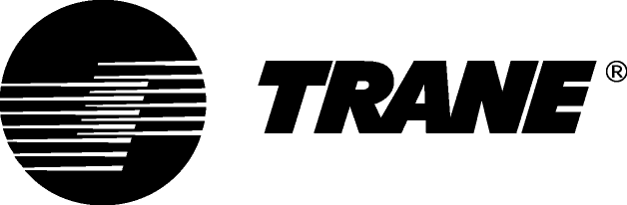

Guide Specifications

Water cooled chillers with helical-rotary compressor

Model RTWD HE G / HSE G with R1234ze refrigerant

Water-cooled 360 - 811 kW

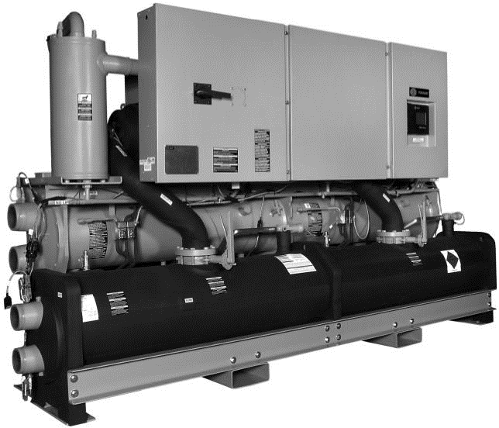

May 2020 RLC-PRG034B-GB

General
Chilled water production will be made by a factory-assembled and tested water-cooled liquid chiller, Trane type RTWD HE G / HSE G….. which will be shipped with a full operating charge of R1234ze refrigerant and lubrication oil, screw compressor and electronic expansion valve.

Unit panels, frames and exposed steel surfaces shall be painted with an air-dry RAL 9002 prior to shipment. Molded neoprene isolation pads shall be supplied for placement under all support points. Startup and operator instructions by factory-trained service personnel are included.

Performances summary
- Cooling capacity at full load:…... (kW)
- Unit power input at full load:.……(kW)
- Operating conditions: Evaporator entering/leaving temperature:..…….(°C).
Condenser entering/leaving temperature:……...(°C).
- Energy efficiency at full load EER:………. (kW/kW)
- Seasonal Energy efficiency SEER:……. (kW/kW)
- Sound power:……… dB(A)

Quality assurance
Chiller will be designed and manufactured under a quality assurance system and environmental management system certified in accordance with standard ISO 9001 and 14001.

Chiller will be tested according standard EN14511, hence certified Eurovent. All chillers will follow a production quality plan to ensure proper operation before being shipped to job site.

Unit construction will be in accordance with the following European directives:
- Pressure Equipment Directive (PED) 97/23/CE
- Machinery Directive (MD) 2006/42/CE
- Low Voltage Directive (LV) 2006/95/CE
- ElectroMagnetic Compatibility Directive (EMC) 2004/108/CE
- Electrical Machinery Safety Standard EN 60204-1
- Electromagnetic Emission and Immunity Standard EN 61800-3 category C3

Compressor and Motor
The unit is equipped with two semi-hermetic, direct-drive, 3000 rpm 50 Hz rotary compressors that include a load/unload valve, rolling element bearings, oil filtration device and heater. The motor is a suction gas-cooled, hermetically sealed, two-pole squirrel cage induction motor. Oil separator device is provided separate from the compressor. Check valves in the compressor discharge and lube oil system and a solenoid valve in the lube system are also provided.
Each one of the rotary compressors is driven by an Adaptive Frequency™ Drive to optimize performances at partial load and act as unit starter.

Evaporator
Dual circuited, shell and tube falling film evaporator design is used. Seamless internally finned, copper tubes are mechanically expanded into tube sheets and mechanically fastened to tube supports. Evaporator tubes are 19.05 mm diameter on high and premium efficiency chillers. All tubes can be individually replaced. Shells and tube sheets are made of carbon steel. Designed, tested, and stamped in accordance with PED code. The evaporator is designed for refrigerant-side/working-side pressure of 14 bars. All water pass arrangements are available with grooved connections with 10 bars waterside working pressure. Waterside shall be hydrostatically tested at 14.5 bars.

Condenser
Dual circuited, shell and tube condenser designed with seamless internally/externally finned tubes expanded into tube sheets and mechanically fastened to tube supports. Condenser tubes are 19.05 mm diameter on high and premium efficiency chillers. All tubes can be individually replaced. Shells and tube sheets are made of carbon steel. Designed, tested, and stamped in accordance with PED code. The condenser is designed for refrigerant-side/working-side pressure of 21 bars. Water side has single inlet and outlet piping connection. All water pass arrangements are available with grooved connections with 10 bars waterside working pressure. Waterside shall be hydrostatically tested at 14.5 bars. Standard temperature condenser allows for leaving condenser water temperature up to 40.6°C and for entering condenser water temperatures up to 35°C.

Refrigerant Circuit
Each unit has two refrigerant circuits, with one rotary screw compressor per circuit. Each refrigerant circuit includes compressor suction and discharge service valves, liquid line shut off valve, removable core filter, charging port and an electronic expansion valve. Modulating compressors and electronic expansion valves provide variable capacity modulation over the entire building load and maintain proper refrigerant flow.

Oil Management
The RTWD chiller is configured with an oil management system that ensures proper oil circulation throughout the unit. The key components of the system include an oil separator, oil filter and gas pump. An optional oil cooler is installed when the unit is used for high condensing temperature or low evaporator temperature conditions; for example: heat recovery, water-water heat pump, ice making and low temperature process applications

Unit-Mounted Star-Delta Starter (RTWD HE G)
The starter is available in a Star-Delta configuration closed transition, factory-mounted and fully pre-wired to the compressor motor and control panel. Starter will reduce 33% the RLA inrush current.

A factory-installed, factory-wired 600VA control power transformer provides all unit control power (120 VAC secondary) and CH530 module power (24 VAC secondary). Optional starter features include circuit breaker, fused disconnect switch, non-fused disconnect switch. All the starter elements will be enclosed in a IP54 panel, with hinged door to allow customer power input connection.

Adaptive Frequency™ Drive (RTWD HSE G)
RTWD HSE G will be equipped with an Adaptive Frequency Drive, factory-mounted, tested and wired. Frequency converter will be chosen by the manufacturer basis on the present motor current at maximum loading of the unit, and will drive the chiller start and ramp up, as long as the partial load operation.
AFD enclosure will be IP54 as standard, with integrated air cooling system, consisting of a fan below the AFD frame, without no obstacle to the air circulation.

Unit Controls (Trane CH530)
The microprocessor-based control panel is factory-installed and factory-tested. The control system is powered by a pre-wired control power transformer, and will load and unload the chiller through adjustment of compressor motor speed through Adaptive Frequency Drive. Microprocessor-based chilled water reset based on return water is standard. The Trane CH530 microprocessor automatically acts to prevent unit shutdown due to abnormal operating conditions associated with low evaporator refrigerant temperature, high condensing temperature, and/or motor current overload. If an abnormal operating condition continues and the protective limit is reached, the machine will shut down.
The panel includes machine protection shutdown requiring manual reset for the following conditions:
• Low evaporator refrigerant temperature and pressure
• High condenser refrigerant pressure
• Low oil flow
• Critical sensor or detection circuit faults
• Motor current overload
• High compressor discharge temperature
• Lost communication between modules
• Electrical distribution faults: phase loss, phase imbalance, or phase reversal
• External and local emergency stop
• Starter transition failure

The panel also includes machine protection shutdown with automatic reset for the following correctable conditions:
• Momentary power loss
• Under/over voltage
• Loss of evaporator or condenser water flow
When a fault is detected, the control system conducts more than 100 diagnostic checks and displays results. The display will identify the fault, indicate date, time, and operating mode at time of occurrence, and provide type of reset required and a help message.

Clear Language Display Panel
Factory-mounted to the control panel door, the operator interface has an LCD touch-screen display for operator input and information output. This interface provides access to the following information: evaporator report, condenser report, compressor report, operator settings, service settings, service tests, and diagnostics. All diagnostics and messages are displayed in clear un-coded language.
Data contained in available reports includes:
• Water and air temperatures
• Refrigerant levels and temperatures
• Oil pressure
• Flow switch status
• EXV poition
• Head pressure control command
• Compressor starts and run-time
• Line phase percent RLA, amps, and volts
All necessary settings and setpoints are programmed into the microprocessor-based controller via the operator interface. The controller is capable of receiving signals simultaneously from a variety of control sources, in any combination, and priority order of control sources can be programmed. The control source with priority determines active setpoints via the signal it sends to the control panel.
Control sources may be:
• Local operator interface (standard)oHard-wired 4-20 mA or 2-10 Vdc signal from an external source (interface optional; control source not supplied
• Time of day scheduling (optional capability available from local operator interface)
• LonTalk™ LCI-C (interface optional; control source not supplied)
• Trane Tracer Summit™ system (interface optional; control source not supplied)

Options

Dual Relief Valve
Unit comes with dual relief valves on both the high pressure side and low pressure side of each refrigerant circuit. Each dual relief valve configuration includes an isolation valve. Single relief valves are standard.

Flanged Water Connection Kit
Kit to convert all four water connection from grooved pipe to flanged connections. This includes: grooved couplings, pipe offsets, and grooved to flange adapters.

High-Temperature Condenser
Optimized compressors, oil cooler and high condenser temperature control panel allows for leaving condenser water temperatures up to 75°C. This option is required for entering condenser water temperatures above 35°C.

Insulation
The evaporator, water boxes, and motor housing are covered with factory installed 19.05 mm Armaflex II or equal (k=0.28) insulation. Factory installed foam insulation is used on the suction line, liquid level sensor, oil return system assembly (with its associated piping).

Insulation for High Humidity
The evaporator and water boxes are covered with factory installed 38.1 mm Armaflex II or equal (k=0.28) insulation. Factory installed foam insulation is used on the motor housing, suction line, liquid level sensor, and oil return system assembly (with its associated piping).

Isolators
Molded elastomeric isolators ship with the unit.

Low-Temperature Evaporator
Optimized compressors and oil cooler enable evaporator operation down to minimum leaving water temperature of -12°C.

Pressure Gauges
A set of two pressure gauges per refrigerant circuit are installed, one for low pressure and one for high pressure.

Water-to-Water Heat Pump
Optimized compressors, oil cooler and high condenser temperature control panel allows for leaving condenser water temperatures up to 75°C. This option allows for entering condenser water temperatures above 35°C Condenser leaving water
temperature control option is required; the setpoint range is up to 75°C.

Electrical Options

Wye-Delta Starter
This option provides a reduced-inrush, unit mounted starter with a IP-55 gasketed enclosure.

Circuit Breaker
A molded case standard interrupting capacity circuit breaker, factory pre-wired with terminal block power connections and equipped with a lockable external operator handle, is available to disconnect the chiller from main power.

Disconnect Switch Wired to Fuses
A fused molded case disconnect switch, factory pre-wired with fuses and equipped with a lockable external operator handle, is available to disconnect the chiller from main power.

IP 20 Protection of Control Panel
Provides protection of all live contacts including the ones which are energized after the disconnect switch is in the “ON” position and the unit is operating with the electrical panel opened. Electrical panel is built in accordance with NF EN 60529 standard.

Under/Over-Voltage Protection
Unit receives protection against variations in voltage (current lag and spike protection is standard).

Control Options

Chilled Water Reset -- Outdoor Air Temperature
Controls, sensors, and safeties allow reset of chilled water temperature, based on temperature signal, during periods of low outdoor air temperature (chilled water reset based on return chilled water temperature is standard).

Condenser Leaving Water Temperature Control
Enables the unit to use the leaving condenser water temperature to load and unload the chiller relative to the leaving condenser water setpoint. The control system allows for a condenser leaving temperature range of 26.7°C to 60°C with a water to water
heat pump.

Condenser Differential Pressure Output
Provides a 2--10 Vdc signal based on the system refrigerant differential pressure and time at the differential with customer defined endpoints.

Condenser Pressure (%HPC) Output
Provides a 2--10 Vdc output that is a function of percent high pressure cutout for condenser pressure. The percent high pressure cutout for condenser pressure indication output is based on the condenser refrigerant pressure transducer(s).

Condenser Water Control Output
Provides a highly configured signal designed to control a Trane supplied condenser water regulating valve.

External Chilled Water or Hot Water Setpoint
External chilled or hot water setpoint signal can be field wired to a factory-installed, tested interface board through a 2--10 Vdc or 4--20 mA signal.

External Current Limiting
External current limit setpoint is communicated to a factory-installed, tested communication board through a 2--10 Vdc or 4--20 mA signal.

LonTalk/Tracer Summit Interface
LonTalk (LCI-C) or Tracer Summit communications capabilities are available, with communication link via single twisted-pair wiring to factory-installed, tested communication board.

Motor Current Analog Output
Control system indicates the active chiller percent of full run load amps, based on a 0--10 Vdc.

Power Meter
Tracks energy consumption (compressors only) with kWh meter.

Programmable Relays
Predefined, factory-installed, programmable relays allow the operator to select four relay outputs. Available outputs are: Alarm-Latching, Alarm-Auto Reset, General Alarm, Warning, Chiller Limit Mode, Compressor Running, Head Pressure Relief Request, and Tracer Control.

Time of Day Scheduling
Time of day scheduling capabilities are available for scheduling single chiller applications through Trane CH530 panel (without the need for building automation system-BAS). This feature allows the user to set up to 10 events in a 7 day time period.

Trane - by Trane Technologies (NYSE: TT), a global climate innovator - creates comfortable, energy efficient indoor environments for commercial and residential applications. For more information,
please visit trane.eu or tranetechnologies.com.
Trane has a policy of continuous product and product data improvement and reserves the right to change design and specifications without notice.

Confidential and proprietary Trane information

RLC-PRG034B-GB_0520 ©2020 Trane
Supersedes RLC-PRG034A_0517

