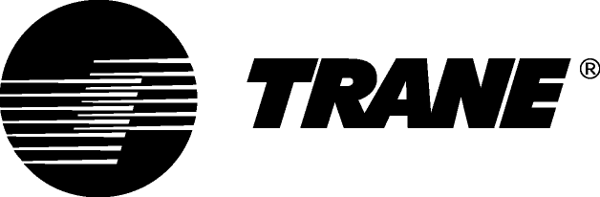

Guide Specifications

Air-cooled Chillers with High Speed Centrifugal Compressors

Model GVAF-X / GVAF-XP / GVAF-XPG

450 - 1600 kW

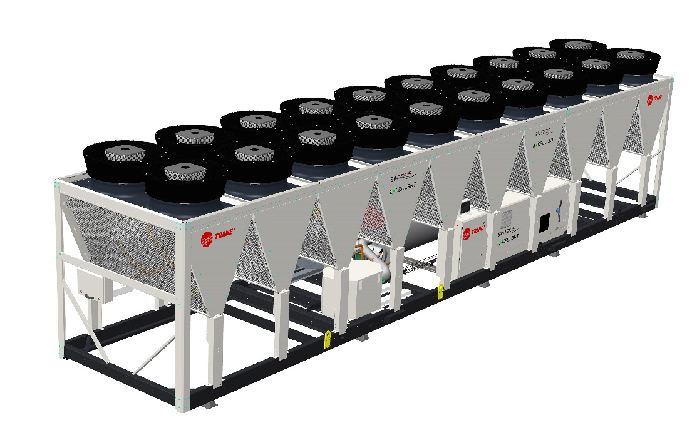

June 2020 CTV-PRG005D-GB
General
Chilled water production will be made by a factory-assembled air-cooled liquid chiller, Trane type GVAF X/XP/XPG. Chiller will have two refrigerant circuits with one or two compressors per circuit, will be shipped with a full operating charge of R134a, R513A or R1234ze refrigerant, centrifugal oil free compressors and electronic expansion valve.
Documentation including installation-operation-maintenance manual, user guide, wiring diagram and submittal is placed in the control panel.

Performances summary
- Cooling capacity at full load:…. (kW)
- Unit power input at full load:……(kW)
- Operating conditions: Evaporator entering/leaving temperature: …./…..(°C).
Air temperature:……...(°C).
- Energy efficiency at full load EER:………. (kW/kW)
- European Seasonal Energy Efficiency Ratio ESEER:……. (kW/kW)
- Sound power level:……… dB(A)

Quality assurance
Chiller is designed and manufactured under a quality assurance system and enviromental management system certified in accordance with ISO 9001:2008 and ISO14001 standards.

Chiller is factory-tested according standard EN14511, and performances are certified by Eurovent. All chillers follow a production quality plan to ensure proper construction and operation.

Unit construction will be in accordance with follow European directives:
- Pressure Equipment Directive (PED) 97/23/CE
- Machinery Directive (MD) 2006/42/CE
- Low Voltage Directive (LV) 2006/95/CE
- ElectroMagnetic Compatibility Directive (EMC) 2004/108/CE
- Electrical Machinery Safety Standard EN 60204-1

Construction Characteristics

Unit panels, frames and exposed steel surfaces will be constructed of galvanized steel, painted and have a corrosion resistance of 675 hours to salt spray test.
Electrical panel will be built of galavanized steel and rated IP54.

Compressors and Motors

The centrifugal oil free compressor is two stage, semi hermetic and direct drive, powered by pulse width modulating voltage supply.
Compressor shall be constructed with cast aluminum casing and high-strength thermoplastic electronics enclosures.
The impellers shall consist of cast and machined aluminum.
The motor rotor and impeller assembly shall be the only major moving parts.
The compressor shall be provided with radial and axial magnetic bearings to levitate the shaft.
Each bearing position shall be sensed by position sensors to provide real-time repositioning of the rotor shaft, controlled by onboard digital electronics.
The compressor shall have a Variable Frequency Drive (VFD) for linear capacity modulation and reduced in-rush starting current.
Compressor shall be equipped with a bank of capacitor to storage energy and a EMC filter to avoid harmonic transfer to the compressor.
Motor cooling shall be by liquid refrigerant injection.

Evaporator

The evaporator is a tube-in-shell heat exchanger design constructed from carbon steel shells and tubesheets with internally and externally finned seamless copper tubes mechanically expanded into the tube sheets. Tubes are cleanable with dismountable water boxes. Tubes diameter is 19mm. . Each tube is individually replaceable.
The evaporator is designed, tested and stamped in accordance with PED 97/23/CE Pressure Vessel Code for a refrigerant side working pressure of 14 bars (200 psig). The evaporator is designed for a water side working pressure of 10.5 bars (150 psig). Standard water connections are grooved for Victaulic type pipe couplings. Waterboxes are available in 2 passes configurations and include a vent, a drain and fittings for temperature control sensors. Evaporator is insulated with Armaflex II or equivalent of 19 mm (3/4 inches) thickness and K factor of 0,26 W/m²°K.

Condenser and Fans

The air-cooled Microchannel condenser coils use all aluminum brazed fin construction. The coil is composed of three
components: the flat microchannel tube, the fins located between the microchannel tubes, and two refrigerant manifolds. Coils
can be cleaned with high pressure water.
The condenser coil has an integral subcooling circuit. The maximum allowable working pressure of the condenser is 25.0 bars. Condensers are factory proof and leak tested at 45 bars.
Direct-drive vertical-discharge airfoil condenser fans are dynamically balanced.
Units are equipped with EC condenser fan motors with permanently lubricated ball bearings and external overload protection are provided. Fans are class F, IP55.

Refrigerant Circuit

Each unit has two refrigerant circuits, with one or two centrifugal compressors per circuit. Each refrigerant circuit includes compressor discharge service valves, motorized suction valve, liquid line shut off valve, removable core filter, charging port, high pressure and low pressure safety valves and electronic expansion valve.

Electrical Panel

Single point connection with disconnect switch and fuses.
The disconnect switch is mechanically interlocked to disconnect line power from the starter before the starter doors are open.
All components and control cables are numbered in accordance with CEI 60750.
A factory-installed, factory-wired control power transformer provides all unit control power and UC800 module power. All the starter elements are enclosed in an IP54 panel, with hinged door.

Unit Controls (Tracer UC800)

The microprocessor-based control panel is factory-installed and factory-tested.

Microprocessor-based chilled water reset based on return water is standard. The UC800 utilizing the “Adaptive ControlTM” microprocessor automatically takes action to prevent unit shutdown due to abnormal operating conditions associated with low evaporator refrigerant temperature, high condensing temperature, and motor current overload. If abnormal operating condition continues and protective limit is reached, the refrigerant circuit will be shut down. Controller includes machine protection shutdown requiring manual reset for:
- Low evaporator refrigerant temperature and pressure
- High condenser refrigerant pressure
- Low oil flow
- Critical sensor or detection circuit fault
- Motor current overload
- High compressor discharge temperature
- Communications lost between modules
- Electrical distribution faults: phase loss, phase imbalance, phase reversal
- External and local emergency stop
- Starter transition failure.
The panel includes machine protection shutdown with automatic reset when the condition is corrected for:
- Momentary power loss
- Over / under voltage
- Loss of evaporator water flow.

Over 100 diagnostic checks is made and are displayed when a fault is detected. The display indicates the fault, the type of reset required, the time and date the diagnostic occurred, the mode in which the machine was operating at the time of the diagnostic, and a help message. A diagnostic history displays the last 20 diagnostics with the time and date of their occurrence. Alarms and diagnostics are displayed in chronological order, with a color/symbol code: red octagon for immediate shutdown, yellow triangle for normal shutdown and blue circle for warning.

Human interface with Touchable Display Trane TD7
• Factory-mounted above the control panel door
• UV Resistant touchscreen
• -40C to 70°C operating temperature
• IP56 rated
• CE certification
• Emissions: EN55011(Class B)
• Immunity: EN61000 (Industrial)
• 7” diagonal
• 800x480 pixels
• TFT LCD @ 600 nits brightness
• 16 bit color graphic display
Display features:
• Alarms
• Reports
• Chiller settings
• Display settings
• Graphing
• Support for 15 languages

Dry contacts
UC800 provides a flexible alarm or chiller status indication to a remote location through a hard wired interface to a dry contact closure. Four relays are available for this function.

Options

Application options

Integrated Variable Primary Flow
Integrated within the chiller controller, a variable primary flow option will allow control of the water flow through the evaporator. This will be based on a proven algorithm modulating the flow rate to minimize pump consumption at full and partial load.
Two options of operating modes will be available:

- Constant Differential Pressure (DP), acting continuously on the pump speed to ensure a constant outlet pressure. This solution is recommended on installations with 2 way valves on the water coils. This method ensures that each branch of the water loop has a uniform supply, without unnecessary energy consumption. This system will ensure that each water terminal has the appropriate differential pressure supply. In order to manage chiller minimum evaporator water flow, a hydronic package will include water pressure transducers to intellingently monitor water flow rate in real time within AdaptiView™ chiller control. Chiller will deliver the control signal for system by-pass valve actuator. System differential pressure is measured by supplied differential pressure transducer.

- Constant Differential Temperature (DT), in this case the chiller controller algorithm will maintain a constant difference in between entering and leaving temperature at the chiller plant (DT), regardless the load, reducing the water flow rate when necessary up to the minimum allowed. This solution can be applied on water loops with 3 way valve systems, and can deliver higher energy savings than precedent logic (constant DP) in the majority of comfort applications.

Free-cooling Control
Chiller controller could supply a control option for an externally supplied dry cooler to implement free-cooling strategy, allowing as per pre-fixed ambient temperature set point, switch from chiller operation to dry cooler operation. Control algorithm will be based on PID logic, return temperature and cooling capacity demand.

Free-cooling Chiller
Chiller can be supplied with option for water based free-cooling, built with all aluminum flat channel dry cooler exchanger, installed in parallel with refrigerant microchannel condenser coil, and a water valve to control the free-cooling capacity. The following options should be available:

- Partial Free-cooling with water on customer water loop (primary/secoundary heat exchanger will be unit mounted)
- Partial Free-cooling with glycol on customer water loop
- Total Free-cooling with water on customer water loop (primary/secoundary heat exchanger will be unit mounted)
- Total Free-cooling with glycol on customer water loop

E-coating
An option to supply MCHE condenser coils with e-coating will be available. This e-coating will withstand the exposure to typical corrosive atmospheres, in shore or industrial locations, without sensible impact on coil performances in what heat transfer and air pressure drop is a concern.

Sound level options

Low noise
All GVAF units are equipped with EC fans, compressors are enclosed in a box and discharge line insulated.
Low noise with NNSB
Night noise set back allow to reduce the sound level of the chiller by reducing the speed of EC fans controlled
with an external on/off contact.
Extra low noise
Extra low noise units are equipped with NNSB and fan diffusers.

Hydraulic module option*
Hydraulic module includes the following components: water strainer, 80 l expansion vessel, pressure relief valve set at 5 bars, twin pump low head allowing a pressure drop in the water circuit up to 120 kPa or twin pump high head allowing a pressure drop in the water circuit up to 220 kPa, balancing valve and anti freeze protection.

Electrical options
- Under/over voltage protection
- IP20 internal protection
- Flow switch: the flow switch is sent as an accessory and must be installed on site.

Control options

BACnet™ communications interface

Allows the user to easily interface with BACnet via a single twisted pair wiring to a factory installed and tested communication board.
LonTalk™ (LCI-C) Communications Interface
Provides the LonMar chiller profile inputs/outputs for use with a generic building automation system via a single twisted pair wiring to a factory installed and tested communication board.
ModBus™ Communications Interface
Allows the user to easily interface with ModBus via a single twisted pair wiring to a factory installed and tested communication board.

External chilled water setpoint
UC800 accepts either a 2-10 VDC or a 4-20mA input signal, to adjust the chilled water setpoint from a remote location.

External current limit setpoint
UC800 accepts either a 2-10VDC or a 4-20mA input signal to adjust the current limit setpoint from a remote location.

Run test report option
Run test report gives the results of the perfomance test of the unit in the design conditions specified in the order write-up with water without glycol.
The data recorded are: cooling capacity, power input, air temperature, water entering temperature, water leaving temperature and water flow.

Other Options

Relief valves

Dual relief valve plus 3-way valve on high and low pressure side.

High performance insulation.
Evaporator is insulated with 2 layers of Armaflex II or equivalent of 19 mm (3/4 inches) thickness and K factor of 0,26 W/m²°K.

Evaporator without insulation
Evaporator is not insulated and a specific insulation can be done on site.

Coated condensing coils
Condensing coils are protected with a cathodic epoxy electrodeposition coating UV resistant.

Neoprene pads
Neoprene pads avoids a direct contact of the base of the unit with the ground.

Neoprene isolators

Isolators provide isolation between chiller and structure to help eliminate vibration transmission and have an efficiency of 95% minimum.

Grooved pipe plus weld coupling
Grooved pipes are connected on water inlet and outlet. The coupling allows connection between the grooved pipe and the evaporator water connection.

Export shipping package
Metallic clogs are fixed on the base frame of the unit. They prevents direct contact between the chiller and the container during loading and unloading from the container.

* Components may differ depending on unit model and size. Contact your local sales office for details.

Trane - by Trane Technologies (NYSE: TT), a global climate innovator - creates comfortable, energy efficient indoor environments for commercial and residential applications. For more information, please visit trane.eu or tranetechnologies.com.
Trane has a policy of continuous product and product data improvement and reserves the right to change design and specifications without notice.

CTV-PRG005D-GB_0620 ©2020 Trane
Supersedes CTV-PRG005C-GB_0220

