Guide Specifications

Water cooled chillers and water-to-water heat pumps with helical-rotary compressor

Model RTWF XSE

405 -1315 kW

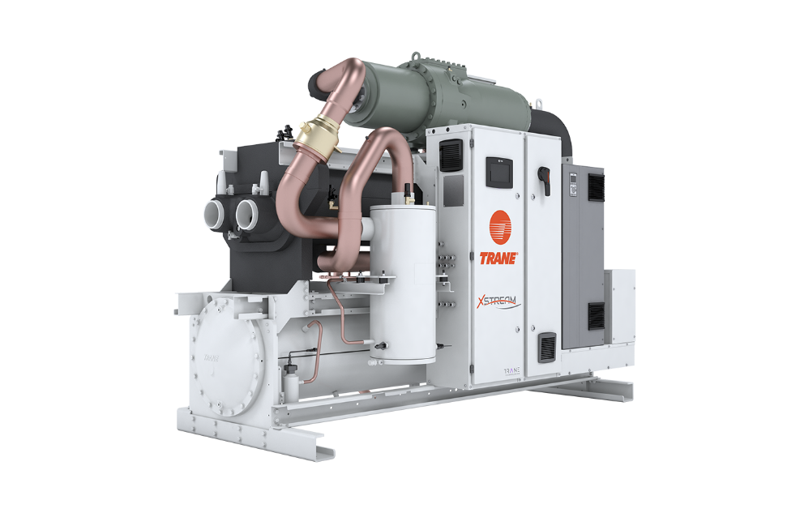

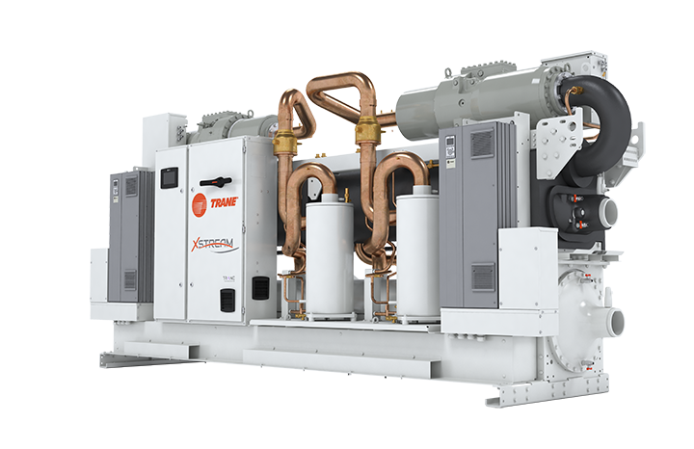

September 2020 RLC-PRG042A-GB
General
Chilled or hot water production will be made by a factory-assembled and tested water-cooled liquid chiller/water-to-water heat pump, Trane type RTWF XSE which will be shipped with a full operating charge of R134a refrigerant and lubrication oil, screw compressor and electronic expansion valve.

Unit panels, frames and exposed steel surfaces shall be painted with an air-dry RAL 9002 and RAL 7016 prior to shipment. Molded neoprene isolation pads shall be supplied for placement under all support points. Startup and operator instructions by factory-trained service personnel are included.

Performances summary
Cooling Performances
- Cooling capacity at full load:…... (kW)
- Unit power input at full load:.……(kW)
- Operating conditions: Evaporator entering/leaving temperature:..…….(°C).
Condenser entering/leaving temperature:……...(°C).
- Energy efficiency at full load EER:………. (kW/kW)
- Seasonal Energy efficiency SEER:……. (kW/kW)
- Sound power:……… dB(A)

Heating Performances
- Heating capacity at full load:…... (kW)
- Unit power input at full load:.……(kW)
- Operating conditions: Evaporator entering/leaving temperature:..…….(°C).
Condenser entering/leaving temperature:……...(°C).
- Energy efficiency at full load COP:………. (kW/kW)
- Sound power:……… dB(A)

Quality assurance
Unit will be designed and manufactured under a quality insurance system and environmental management system certified in accordance with standard ISO 9001 and 14001.

Unit will be tested according to standard EN14511, hence Eurovent and AHRI certified. All units will follow a production quality plan to ensure proper operation before being shipped to job site.

Unit construction will be in accordance with the following European directives:
- Pressure Equipment Directive (PED) 2014/68/EU
- Machinery Directive (MD) 2006/42/CE
- Low Voltage Directive (LV) 2006/95/CE
- ElectroMagnetic Compatibility Directive (EMC) 2004/108/CE
- Electrical Machinery Safety Standard EN 60204-1
- Electromagnetic Emission and Immunity Standard EN 61800-3 category C3

Compressor and Motor
The screw compressor is semi-hermetic, direct drive, with motor ranging from 1700 to 5800 rpm or 1400 to 5250 rpm depending on the model, differential refrigerant pressure oil circulation system without oil pump, and with oil heaters.
On series Trane RTWF XSE, capacity control is achieved through the AFD to optimize performances at partial load allowing reduction of capacity down to 35% or 38% of the maximum value (depending on the model).
Compressor will start always unloaded.
Motor is suction gas cooled, hermetically sealed, 6 poles, permanent magnet type, with four pressure lubricated rolling elements, bearing groups shall support the rotating assembly. Motor bearings will be designed for the whole life of the unit.
RTWF XSE are equipped with 1 or 2 compressors.

Oil Management

The unit is equipped with an oil management system without oil pump that ensures proper oil circulation throughout the unit. The key components of the system include an oil separator, oil filter with particles retention capacity of at least 5µm.
An oil heater is installed to avoid startup with low oil temperature.

Adaptive Frequency™ Drive (AFD)

Compressors of RTWF XSE shall be equipped with an Adaptive Frequency™ Drive, factory-mounted, tested and wired. Frequency converter will drive the unit start and ramp up, and the partial load operation.
AFD enclosure is IP55 as standard, with integrated air cooling system, consisting of a fan below the AFD frame.

Evaporator

Single circuited / double pass (Sizes 115 and 175) or dual circuited Simple pass (Sizes 235, 305 and 375), tube-in-shell heat exchanger design constructed from carbon steel shells and tube sheets with internally and externally finned seamless copper tubes mechanically expanded into the tube sheets. Tubes are cleanable with dismountable water boxes. Tubes diameter is 19mm. Each tube is individually replaceable.
The evaporator is designed, tested and stamped in accordance with PED 2014/68/EU Pressure Vessel Code for a refrigerant side working pressure of 14 bars (200 psig). The evaporator is designed for a water side working pressure of 10.0 bars. Standard water connections are grooved for Victaulic type pipe couplings. Waterboxes are available in 1 passes configuration and include a vent, a drain and fittings for temperature control sensors. Evaporator is insulated with Armaflex II or equivalent of 19 mm (3/4 inches) thickness and K factor of 0,26 W/m²°K.

Condenser
Single circuited / double pass (Sizes 115 and 175) or dual circuited / simple or double pass (Sizes 235, 305 and 375) shell and tube condenser designed with seamless internally/externally finned tubes expanded into tube sheets and mechanically fastened to tube supports. Condenser tubes are 19.05 mm diameter. All tubes can be individually replaced. Shells and tube sheets are made of carbon steel. Designed, tested, and stamped in accordance with PED code. The condenser is designed for refrigerant-side working-side pressure of 25 bars. Water side has single inlet and outlet piping connection. Water connections are available with grooved connections with 10 bars waterside working pressure.
Standard temperature condenser allows for leaving condenser water temperature up to 68°C and for entering condenser water temperatures up to 63°C.
Condenser are equipped with a refrigerant liquid level measurement to insure optimum subcooling in all operation conditions.

Refrigerant Circuit

Sizes 115 and 175 have one circuit with one rotary compressor and Sizes 235, 305 and 375 have two rotary screw compressors per circuit. Each refrigerant circuit includes compressor discharge service valves, liquid line shut off valve, charging port, high pressure safety valves and electronic expansion valve.

Unit Controls (Symbio™ 800)
The microprocessor-based control panel is factory-installed and factory-tested. The control system is powered by a control power transformer. It loads and unloads the unit through through the Adaptive Frequency™ Drive.

Microprocessor-based water temperature setpoint reset based on return water is standard. The Symbio controls utilizing the “Adaptive ControlTM” microprocessor automatically takes action to prevent unit shutdown due to abnormal operating conditions associated with low evaporator refrigerant temperature, high condensing temperature, and motor current overload. If abnormal operating condition continues and protective limit is reached, the refrigerant circuit will be shut down. Controller includes machine protection shutdown requiring manual reset for:
- Low evaporator refrigerant temperature and pressure
- High condenser refrigerant pressure
- Low oil flow
- Critical sensor or detection circuit fault
- Motor current overload
- High compressor discharge temperature
- Communications lost between modules
- Electrical distribution faults monitored by AFD
- External and local emergency stop
- AFD failure.

The panel includes machine protection shutdown with automatic reset when the condition is corrected for:
- Momentary power loss
- Over / under voltage monitored by AFD
- Loss of evaporator water flow
- Loss of condenser water flow

Over 100 diagnostic checks is made and are displayed when a fault is detected. The display indicates the fault, the type of reset required, the time and date the diagnostic occurred, the mode in which the machine was operating at the time of the diagnostic, and a help message. A diagnostic history displays the last 20 diagnostics with the time and date of their occurrence. Alarms and diagnostics are displayed in chronological order, with a color/symbol code: red octagon for immediate shutdown, yellow triangle for normal shutdown and blue circle for warning.

Human interface with Touch Display Trane TD7
• Factory-mounted by the side of control panel
• UV Resistant touchscreen
• -40C to 70°C operating temperature
• IP56 rated
• CE certification
• Emissions: EN55011 (Class B)
• Immunity: EN61000 (Industrial)
• 7” diagonal
• 800x480 pixels
• TFT LCD @ 600 nits brightness
• 16 bit color graphic display

Display features:
• Alarms
• Reports
• Unit settings
• Display settings
• Graphing
• Support for 15 languages

Dry contacts
Symbio provides a flexible alarm or unit status indication to a remote location through a hard wired interface to a dry contact closure. Four relays are available for this function.

Options

Application options

High Temperature condenser
Optimized compressors, oil cooler and high condenser temperature control panel allows for leaving condenser water temperatures up to 68°C. This option allows for entering condenser water temperatures above 35°C.

Water-to-Water Heat Pump
Optimized compressors, oil cooler and high condenser temperature control panel allows for leaving condenser water temperatures up to 68°C. This option allows for entering condenser water temperatures above 35°C. Condenser leaving water
temperature control option is required; the setpoint range is 68°C.

Integrated Variable Primary Flow
Integrated within the unit controller, a variable primary flow option will allow control of the water flow through the evaporator and or condenser. This will be based on a proven algorithm modulating the flow rate to minimize pump consumption at full and partial load.

- Constant Differential Temperature (DT), the unit controller algorithm will maintain a constant difference in between entering and leaving temperature at the chiller plant (DT), regardless the load, reducing the water flow rate when necessary up to the minimum allowed. This solution can be applied on water loops with variable speed water pump (provides a 0-10 Vdc output to control pump speed) and can deliver higher energy savings than precedent logic (constant DP) in the majority of comfort applications.

Ice making

The ice making option provides special control logic to handle low temperature brine applications (less than 4.4°C leaving evaporator temperature) for thermal storage applications.

Acoustic options
Compressor sound enclosure
An optional unit isolation allows for a sound Power Level reduction of -3dB(A).

Electrical options
- Power protection by circuit breakers
- Ground fault protection
- Over current protection
- IP20 internal protection
- Flow switch: the flow switches are sent as an accessory and must be installed on site on evaporator or condenser or both.
- 230 V power socket

Control Options

Master/slave operation (2 units)
Master and slave units are supplied with two additional cards in order to communicate with each other in a plant connected through the means of a dry contact output to a remote auto/stop input. Unit configured as master will lead the plant and slave unit will follow master’s operation.

BACnet™ MSTP Communication interface

Allows the user to easily interface with BACnet MSTP via a single twisted pair wiring to a factory installed and tested communication board.

BACnet™ IP Communication interface

Allows the user to easily interface with BACnet IP via a single Ethernet cable to a factory installed and tested communication control.
ModBus™ RTU Communications Interface
Allows the user to easily interface with ModBus via a single twisted pair wiring to a factory installed and tested communication board.
LonTalk™ (U60) Communication Interface
Provides the LonMark chiller profile inputs/outputs for use with a generic building automation system via a single twisted pair wiring to a factory installed and tested communication board.

Water Temperature Setpoint Reset - Outdoor Air Temperature
Controls, sensors, and safeties allow reset of chilled water temperature, based on temperature signal, during periods of low outdoor air temperature (chilled water reset based on return chilled water temperature is standard).

Condenser Leaving Water Temperature Control
Enables the unit to use the leaving condenser water temperature to load and unload the unit relative to the leaving condenser water setpoint. The control system allows for a condenser leaving temperature range of 27°C to 65°C with a water-to-water heat pump.

Condenser Differential Pressure Output
Provides a 0-10 Vdc signal based on the system refrigerant differential pressure with customer defined endpoints.

Condenser Pressure (%HPC) Output
Provides a 0-10 Vdc output that is a function of percent high pressure cutout for condenser pressure. The percent high pressure cutout for condenser pressure indication output is based on the condenser refrigerant pressure transducer(s).

Condenser Water Control Output
Provides a 0-10 Vdc output to allow control of a condenser water regulating valve.

External Setpoint Package
External signals can be field wired to a factory-installed, tested interface board through a 2--10 Vdc or 4--20 mA signal which are:
- External chilled or hot water setpoint
- External demand limit setpoint
External signal can be field wired to a factory-installed, tested interface board through a digital input to remotely activate an auxiliary chilled/hot water setpoint which can be customer defined.
The factory-installed, tested interface board provides a unit %RLA signal through a 0-10Vdc analog output.

Power Meter
Tracks energy consumption (compressors only) with kWh meter.

Other Options

Single relief valve on evaporator
Unit comes with single relief valves on both the high pressure side and low pressure side of each refrigerant circuit. Single relief valves on condenser are standard.

Dual relief valve with bypass valve
Unit comes with dual relief valves on both the high pressure side and low pressure side of each refrigerant circuit. Each dual relief valve configuration includes an isolation valve. Single relief valves are standard.

Grooved pipe plus weld coupling
Grooved pipes are connected on water inlet and outlet. The coupling allows connection between the grooved pipe and the evaporator water connection. Couplings can be supplied for evaporator or condenser only or both.

Left or Right hand connection
On Single circuit units (Sizes 115 and 175) Evaporator and/or Condenser are fitted so water connections can be either on the left or on the right.

No cold parts insulation
Should specific insulation be applied on site, unit can be delivered without insulation of cold parts.

Condenser insulation
Insulation of condenser shell for heat pump operation to avoid heat waste.

Neoprene isolators

Isolators provide isolation between unit and structure to help eliminate vibration transmission and have a minimum efficiency of 95%.

Trane - by Trane Technologies (NYSE: TT), a global climate innovator - creates comfortable, energy efficient indoor environments for commercial and residential applications. For more information, please visit trane.eu or tranetechnologies.com.
Trane has a policy of continuous product and product data improvement and reserves the right to change design and specifications without notice.

RLC-PRG042A-GB_0920 ©2020 Trane
New

