Guide Specifications

Water cooled chillers with helical-rotary compressor

Model RTHF XE / HSE

1155 - 3620 kW

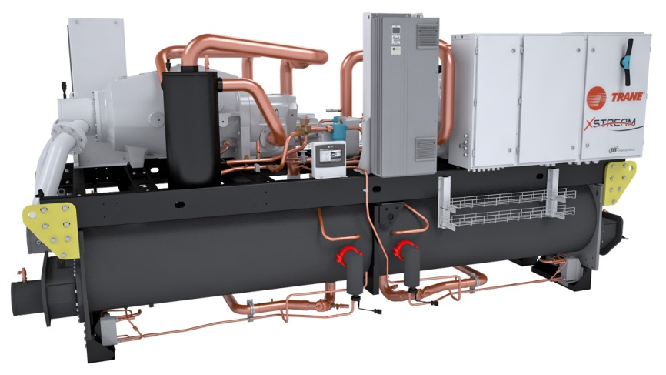

April 2020 RLC-PRG032BD-GB
General
Chilled water production will be made by a factory-assembled and tested water-cooled liquid chiller, Trane type RTHF XE / HSE….. which will be shipped with a full operating charge of R134a refrigerant and lubrication oil, screw compressor and electronic expansion valve.

Unit panels, frames and exposed steel surfaces shall be painted with an air-dry RAL 9002 and RAL 7016 prior to shipment. Molded neoprene isolation pads shall be supplied for placement under all support points. Startup and operator instructions by factory-trained service personnel are included.

Performances summary
Cooling Performances
- Cooling capacity at full load:…... (kW)
- Unit power input at full load:.……(kW)
- Operating conditions: Evaporator entering/leaving temperature:..…….(°C).
Condenser entering/leaving temperature:……...(°C).
- Energy efficiency at full load EER:………. (kW/kW)
- Seasonal Energy efficiency SEER:……. (kW/kW)
- Sound power:……… dB(A)

Quality assurance
Chiller will be designed and manufactured under a quality assurance system and environmental management system certified in accordance with standard ISO 9001 and 14001.

Chiller will be tested according to standard EN14511, hence AHRI certified. All chillers will follow a production quality plan to ensure proper operation before being shipped to job site.

Unit construction will be in accordance with the following European directives:
- Pressure Equipment Directive (PED) 97/23/CE
- Machinery Directive (MD) 2006/42/CE
- Low Voltage Directive (LV) 2006/95/CE
- ElectroMagnetic Compatibility Directive (EMC) 2004/108/CE
- Electrical Machinery Safety Standard EN 60204-1
- Electromagnetic Emission and Immunity Standard EN 61800-3 category C3

Compressor and Motor

The screw compressor is semi-hermetic, direct drive, 3000 rpm or 3600 rpm on overspeed models, differential refrigerant pressure oil circulation system without oil pump, and with oil heater.
On series Trane RTHF HSE, capacity control is achieved through the AFD to optimize performances at partial load allowing reduction of capacity down to 15% of the maximum value.
On series Trane RTHF XE, capacity control will be achieved through a slide valve allowing reduction of capacity down to 15% of the maximum value. Compressor will start always unloaded.
Motor is suction gas cooled, hermetically sealed, two poles, squirrel cage induction type, with four pressure lubricated rolling elements, bearing groups shall support the rotating assembly. Motor bearings will be designed for the whole life of the chiller.
RTHF XE and HSE are equipped with 2 compressors.

Oil Management

The chiller is equipped with an oil management system without oil pump that ensures proper oil circulation throughout the unit. The key components of the system include an oil separator, oil filter with particles retention capacity of at least 5µm.
An oil heater is installed to avoid startup with low oil temperature.
An optional oil cooler is installed when the unit is used for high condensing temperature or low evaporator temperature conditions.
The oil cooler is also installed on all units with Adaptive Frequency™ Drive (HSE versions).

Unit-Mounted Wye-Delta Starter (RTHF XE)

The compressor starters shall be Star-Delta configuration closed transition, factory-mounted and fully pre-wired to the compressor motor and control panel. Starter will reduce by 33% the inrush current.

Adaptive Frequency™ Drive (AFD) mounted on RTHF HSE

Compressors of RTHF HSE shall be equipped with an adaptive frequency drive, factory mounted, tested and wired. Frequency converter will drive the chiller start and ramp up, and the partial load operation.
AFD enclosure is IP55 as standard, with integrated air cooling system, consisting of a fan below the AFD frame.

Evaporator

The evaporator is a tube-in-shell heat exchanger design constructed from carbon steel shells and tubesheets with internally and externally finned seamless copper tubes mechanically expanded into the tube sheets. Tubes are cleanable with dismountable water boxes. Tubes diameter is 19mm. Each tube is individually replaceable.
The evaporator is designed, tested and stamped in accordance with PED 97/23/CE Pressure Vessel Code for a refrigerant side working pressure of 14 bars (200 psig). The evaporator is designed for a water side working pressure of 10.0 bars. Standard water connections are grooved for Victaulic type pipe couplings. Waterboxes are available in 1 passes configuration and include a vent, a drain and fittings for temperature control sensors. Evaporator is insulated with Armaflex II or equivalent of 19 mm (3/4 inches) thickness and K factor of 0,26 W/m²°K.

Condenser

Dual circuited, shell and tube condenser designed with seamless internally/externally finned tubes expanded into tube sheets and mechanically fastened to tube supports. Condenser tubes are 19.05 mm diameter. All tubes can be individually replaced. Shells and tube sheets are made of carbon steel. Designed, tested, and stamped in accordance with PED code. The condenser is designed for refrigerant-side working-side pressure of 16 bars. Water side has single inlet and outlet piping connection. All water pass arrangements are available with grooved connections with 10 bars waterside working pressure. Waterside shall be hydrostatically tested at 14.5 bars. Standard temperature condenser allows for leaving condenser water temperature up to 46°C and for entering condenser water temperatures up to 41°C.

Refrigerant Circuit

Each unit has two refrigerant circuits, with one rotary screw compressor per circuit. Each refrigerant circuit includes compressor discharge service valves, liquid line shut off valve, charging port, high pressure safety valves and electronic expansion valve.

Unit Controls (Tracer UC800)

The microprocessor-based control panel is factory-installed and factory-tested. The control system is powered by a control power transformer. It loads and unloads the chiller through adjustment of the compressor slide valve on models RTHF XE and through an Adaptive Frequency™ Drive on the model RTHF HSE.

Microprocessor-based water temperature setpoint reset based on return water is standard. The UC800 utilizing the “Adaptive ControlTM” microprocessor automatically takes action to prevent unit shutdown due to abnormal operating conditions associated with low evaporator refrigerant temperature, high condensing temperature, and motor current overload. If abnormal operating condition continues and protective limit is reached, the refrigerant circuit will be shut down. Controller includes machine protection shutdown requiring manual reset for:
- Low evaporator refrigerant temperature and pressure
- High condenser refrigerant pressure
- Low oil flow
- Critical sensor or detection circuit fault
- Motor current overload
- High compressor discharge temperature
- Communications lost between modules
- Electrical distribution faults: phase loss, phase imbalance, phase reversal
- External and local emergency stop
- Starter transition failure.

The panel includes machine protection shutdown with automatic reset when the condition is corrected for:
- Momentary power loss
- Over / under voltage
- Loss of evaporator water flow
- Loss of condenser water flow

Over 100 diagnostic checks is made and are displayed when a fault is detected. The display indicates the fault, the type of reset required, the time and date the diagnostic occurred, the mode in which the machine was operating at the time of the diagnostic, and a help message. A diagnostic history displays the last 20 diagnostics with the time and date of their occurrence. Alarms and diagnostics are displayed in chronological order, with a color/symbol code: red octagon for immediate shutdown, yellow triangle for normal shutdown and blue circle for warning.

Human interface with Touch Display Trane TD7
• Factory-mounted by the side of the control panel
• UV Resistant touchscreen
• -40C to 70°C operating temperature
• IP56 rated
• CE certification
• Emissions: EN55011 (Class B)
• Immunity: EN61000 (Industrial)
• 7” diagonal
• 800x480 pixels
• TFT LCD @ 600 nits brightness
• 16 bit color graphic display

Display features:
• Alarms
• Reports
• Chiller settings
• Display settings
• Graphing
• Support for 15 languages

Dry contacts
UC800 provides a flexible alarm or chiller status indication to a remote location through a hard wired interface to a dry contact closure. Four relays are available for this function.

Options

Application options

Integrated Variable Primary Flow
Integrated within the chiller controller, a variable primary flow option will allow control of the water flow through the evaporator and or condenser. This will be based on a proven algorithm modulating the flow rate to minimize pump consumption at full and partial load.

- Constant Differential Temperature (DT), the chiller controller algorithm will maintain a constant difference in between entering and leaving temperature at the chiller plant (DT), regardless the load, reducing the water flow rate when necessary up to the minimum allowed. This solution can be applied on water loops with 3 way valve systems, and can deliver higher energy savings than precedent logic (constant DP) in the majority of comfort applications.

Ice making

The ice making option provides special control logic to handle low temperature brine applications (less than 4.4°C leaving evaporator temperature) for thermal storage applications.

Low temperature brine

Low temperature option provides special control logic and oil cooler is installed to handle low temperature brine applications including part load conditions below 4.4°C leaving evaporator temperature.

Electrical options
- Dual point power supply
- Power protection by circuit breakers
- Under/over voltage protection
- Ground fault protection
- Over current protection
- IP20 internal protection
- Flow switch: the flow switches are sent as an accessory and must be installed on site on evaporator or condenser or both
- 230 V power socket

Control Options

Master/slave operation
Master and slave units are supplied with two additional cards in order to communicate with each other in a plant connected through the means of a dry contact output to a remote auto/stop input. Unit configured as master will lead the plant and slave unit will follow master’s operation.

BACnet™ MSTP Communication interface

Allows the user to easily interface with BACnet MSTP via a single twisted pair wiring to a factory installed and tested communication board.

BACnet™ IP Communication interface

Allows the user to easily interface with BACnet IP via a single Ethernet cable to a factory installed and tested communication board.
ModBus™ RTU Communications Interface
Allows the user to easily interface with ModBus via a single twisted pair wiring to a factory installed and tested communication control.
LonTalk™ (LCI-C) Communication Interface
Provides the LonMark chiller profile inputs/outputs for use with a generic building automation system via a single twisted pair wiring to a factory installed and tested communication board.

Water Temperature Setpoint Reset - Outdoor Air Temperature
Controls, sensors, and safeties allow reset of chilled water temperature, based on temperature signal, during periods of low outdoor air temperature (water temperature setpoint reset based on return chilled water temperature is standard).

Condenser Differential Pressure Output
Provides a 0-10 Vdc signal based on the system refrigerant differential pressure with customer defined endpoints.

Condenser Pressure (%HPC) Output
Provides a 0-10 Vdc output that is a function of percent high pressure cutout for condenser pressure. The percent high pressure cutout for condenser pressure indication output is based on the condenser refrigerant pressure transducer(s).

Condenser Water Control Output
Provides a 0-10 Vdc output to allow control of a condenser water regulating valve.

External Setpoint Package
External signals can be field wired to a factory-installed, tested interface board through a 2--10 Vdc or 4--20 mA signal which are:
- External chilled or hot water setpoint
- External demand limit setpoint
External signal can be field wired to a factory-installed, tested interface board through a digital input to remotely activate an auxiliary chilled/hot water setpoint which can be customer defined.
The factory-installed, tested interface board provides a chiller %RLA signal through a 0-10Vdc analog output.

Power Meter
Tracks energy consumption (compressors only) with kWh meter.

Other Options

Single relief valve on evaporator
Unit comes with single relief valves on both the high pressure side and low pressure side of each refrigerant circuit. Single relief valves on condenser are standard.

Dual relief valve with bypass valve
Unit comes with dual relief valves on both the high pressure side and low pressure side of each refrigerant circuit. Each dual relief valve configuration includes an isolation valve. Single relief valves are standard.

Grooved pipe plus weld coupling
Grooved pipes are connected on water inlet and outlet. The coupling allows connection between the grooved pipe and the evaporator water connection. Couplings can be supplied for evaporator or condenser only or both.

Left or Right hand connection
Unit comes with an additional pipe to allow supply or return on the same side of the unit. Connection can be supplied for evaporator or condenser only or both.

No cold parts insulation
Should specific insulation be applied on site, unit can be delivered without insulation of cold parts.

Condenser insulation
Insulation of condenser and warm parts to avoid heat waste.

Neoprene pads
Neoprene pads avoids a direct contact of the base of the unit with the ground.

Neoprene isolators

Isolators provide isolation between chiller and structure to help eliminate vibration transmission and have a minimum efficiency of 95%.

Trane - by Trane Technologies (NYSE: TT), a global climate innovator - creates comfortable, energy efficient indoor environments for commercial and residential applications. For more information, please visit trane.eu or tranetechnologies.com.
Trane has a policy of continuous product and product data improvement and reserves the right to change design and specifications without notice.

RLC-PRG032D-GB_0420 ©2020 Trane
Supersedes RLC-PRG032C_0517

